Acts 28:1-31
使徒行传28:1-31
The island on which Paul was to live for the next three months was Malta, sixty miles from the nearest tip of Sicily. This egg shaped island was 29 kilometers (18 miles) long and 13 kilometers(8 miles) wide. On the southwest coast the high cliffs descend abruptly to the sea but on the northeast coast there are many inlets and bays. The inhabitants of Malta were of Phoenician extraction (northern Africa) and spoke the Punic language. Paul would have been able to communicate in that language since it is related to Hebrew.
保罗接下来生活了三个月的岛名叫马耳他，距离西西里最近点有60英里。这个蛋形的岛屿有29公里（18英里）长，13公里（8英里）宽。它的西南端是临海的陡峭悬崖，但东北面的海岸有很多小港和海湾。马耳他岛的居民的祖先是腓尼基人（北非），他们的语言是古迦太基语。保罗可能能够使用这种语言与他们交流，因为这种语言和希伯来文有亲缘关系。
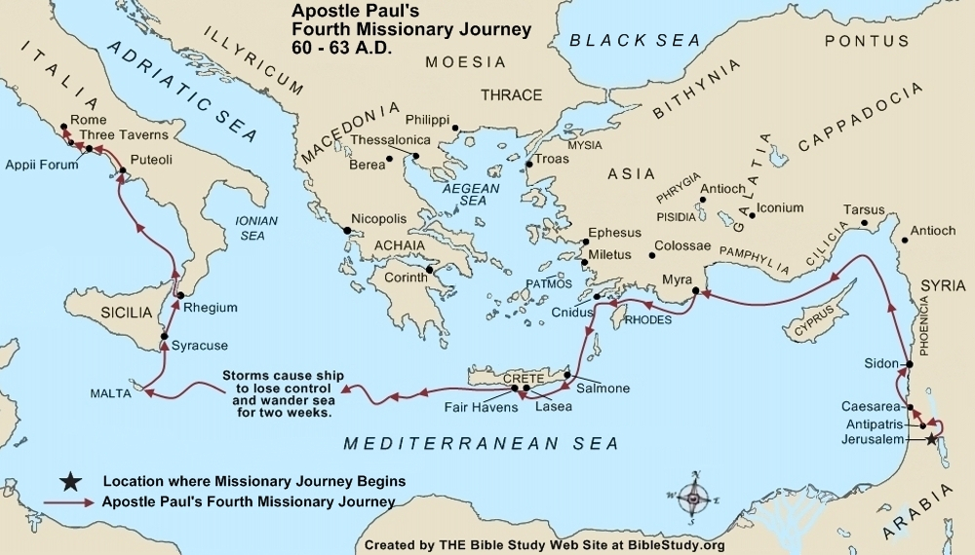

Paul Ashore on Malta
¹ Once safely on shore, we found out that the island was called Malta. Where did the ship run around? ² The islanders showed us unusual kindness. They built a fire and welcomed us all because it was raining and cold. What is unusual about the islanders showing kindness? ³ Paul gathered a pile of brushwood and, as he put it on the fire, a viper, driven out by the heat, fastened itself on his hand. What does it mean that the snake (viper) fastened onto Paul's hand? ⁴ When the islanders saw the snake hanging from his hand, they said to each other, “This man must be a murderer; for though he escaped from the sea, the goddess Justice has not allowed him to live.”What conclusion did the islanders make when they saw the snake attached to Paul's hand? ⁵ But Paul shook the snake off into the fire and suffered no ill effects. ⁶ The people expected him to swell up or suddenly fall dead; Why were the people surprised when Paul did not die? but after waiting a long time and seeing nothing unusual happen to him, they changed their minds and said he was a god. Who did the islanders think Paul was?
⁷ There was an estate nearby that belonged to Publius, the chief official of the island. He welcomed us to his home and showed us generous hospitality for three days. How did Publius treat Paul? ⁸ His father was sick in bed, suffering from fever and dysentery. What was wrong with Publius' father? Paul went in to see him and, after prayer, placed his hands on him and healed him. What did Paul do when he was with Publius' father? ⁹ When this had happened, the rest of the sick on the island came and were cured. How did Paul respond when others who were sick came to him? ¹⁰ They honored us in many ways; and when we were ready to sail, they furnished us with the supplies we needed. How did the islanders further honor Paul?
保罗在马耳他岛上
¹ 我们既已得救，才知道那岛名叫马耳他。这艘船跑到了哪里？² 土人看待我们，有非常的情分；因为当时下雨，天气又冷，就生火接待我们众人。土人待他们有什么不寻常？³ 那时，保罗拾起一捆柴，放在火上，有一条毒蛇，因为热了出来，咬住他的手。毒蛇咬住了保罗的手意味着什么？⁴ 土人看见那毒蛇悬在他手上，就彼此说：「这人必是个凶手，虽然从海里救上来，天理还不容他活着。」当土人看见毒蛇悬在保罗手上时，他们是怎样想的？⁵ 保罗竟把那毒蛇甩在火里，并没有受伤。⁶ 土人想他必要肿起来，或是忽然仆倒死了；当土人发现保罗没有死时，他们为什么感到惊奇？看了多时，见他无害，就转念，说：「他是个神。」土人认为保罗是怎样的身份？
⁷ 离那地方不远，有田产是岛长部百流的；他接纳我们，尽情款待三日。部百流是怎样接待保罗的？⁸ 当时，部百流的父亲患热病和痢疾躺着。部百流的父亲怎样了？保罗进去，为他祷告，按手在他身上，治好了他。保罗见到部百流的父亲时，他做了什么？⁹ 从此，岛上其余的病人也来，得了医治。当其余的病人来见保罗时，他是怎样接待的？¹⁰ 他们又多方地尊敬我们；到了开船的时候，也把我们所需用的送到船上。当地的土人又是怎样尊敬保罗？

Notes注释:
Viper - A snake that is poisonous and has the ability to stretch its jaws wider than most types of snakes in order to deliver venom effectively. The fangs of all viper snakes are hollow, which allows them to inject the poison into prey during a bite. Both the fangs can rotate so that they are hidden away while not in use.
毒蛇 - 一种有毒的蛇，可以比其它蛇更大的扩张它的下颌以使毒液更有效的释放出来。它的毒牙是中空的，可以使其在咬住猎物的时候将毒液注射进去。并且毒牙是可旋转的，以使它们在不使用的时候可以隐藏起来。

Dysentery - An inflammatory disorder of the lower intestinal tract, usually caused by a bacteria. The infection results in pain, fever, and severe diarrhea, often accompanied by the passage of blood and mucus.
痢疾 - 一种下腹部肠道的炎性功能紊乱，通常由细菌引起。这种传染病会引起疼痛和严重的腹泻，排脓血便。

Paul’s Arrival at Rome
¹¹ After three months we put out to sea in a ship that had wintered in the island—it was an Alexandrian ship with the figurehead of the twin gods Castor and Pollux. What do you think Paul did for the three months he was on Malta? ¹² We put in at Syracuse and stayed there three days. Find Syracuse on the map. How long did the ship stay? ¹³ From there we set sail and arrived at Rhegium. The next day the south wind came up, and on the following day we reached Puteoli. What did the south wind allow? ¹⁴ There we found some brothers and sisters who invited us to spend a week with them. How do we know Paul had won the confidence of the centurion? What type of activity was Paul probably involved with while in Puteoli? And so we came to Rome. ¹⁵ The brothers and sisters there had heard that we were coming, and they traveled as far as the Forum of Appius and the Three Taverns to meet us. Were they in Rome yet? Where did the brothers and sisters come from? At the sight of these people Paul thanked God and was encouraged. The Christians in Rome had already received Paul's letter to the Romans. ¹⁶ When we got to Rome, Paul was allowed to live by himself, with a soldier to guard him. What do we learn about Paul's captivity in Rome?
保罗抵达罗马
¹¹过了三个月，我们上了亚历山大的船往前行；这船以「宙斯双子」为记，是在那海岛过了冬的。你认为在这三个月里保罗在马耳他岛上都做了什么？¹²到了叙拉古，我们停泊三日；在地图上找到叙拉古，这艘船停留了多久？¹³又从那里绕行，来到利基翁。过了一天，起了南风，第二天就来到部丢利。南风有什么影响？¹⁴在那里遇见弟兄们，请我们与他们同住了七天。我们怎样知道保罗是否赢的了百夫长的信任？保罗在部丢利的行动是什么性质的？这样，我们来到罗马。¹⁵那里的弟兄们一听见我们的信息就出来，到亚比乌市和三馆地方迎接我们。他们到了罗马了吗？这些弟兄姐妹们从哪里来？保罗见了他们，就感谢 神，放心壮胆。在罗马的弟兄姐妹们已经收到了保罗写的罗马书。¹⁶进了罗马城，保罗蒙准和一个看守他的兵另住在一处。我们从保罗在罗马的囚禁中学到了什么？

Notes注释:
Castor and Pollux - the mythological twins brothers of Helen of Troy. Castor was famous for taming and managing horses, and Pollux for skill in boxing. The Greek god Poseidon, had given them power over wind and waves. Castor and Pollux came to be considered the patron deities of seamen and voyagers after a storm stopped and stars appeared above their heads. They were identified with the two highest and brightest stars of the constellation Gemini.
宙斯双子 - 这对神话中的双胞胎兄弟是特洛伊的海伦公主的兄弟。卡斯托尔擅长驯马和马术，波吕克斯擅长拳击。希腊神明波塞冬赐给他们俩能力可以控制风浪。在一场暴风雨止息后，有星星出现在卡斯托尔和波吕克斯的额头上，因此他们被认为是航海者和水手的守护神。他们代表着两个最高、最亮的双子星座。

Syracuse - The leading city on the island of Sicily, situated on the east coast. It was founded in 735 B.C. In 212 B.C. it was captured by the Romans. Now the island belongs to Italy.
叙拉古 - 西西里岛上重要的城市，座落在东海岸。这座城市建立于公元前735年。在公元前212年被罗马占领。现在这座岛属于意大利。

Rhegium - A town on the coast of Italy, near the southwestern tip.
利基翁 - 在意大利海岸的一座城市，挨近西南角。
Puteoli - Located in the Bay of Naples; it was the chief port for Rome and the arrival of Alexandrian grain ships.
部丢利 - 座落在那不勒斯海湾；这事罗马的主要港口，也是从亚历山大来的运粮船到达的主要港口。

Forum of Appius - Forum means "market place". Appius was named after the Roman Appius Claudius, who also built the Appian Way some 350 years ago.
亚比乌市 - 市是指“市场”。亚比乌是以罗马人阿庇乌斯克劳蒂命名，他还曾在350年之前建造了亚壁古道。

Three Taverns - The word "tavern" was used to designate any kind of shop.
三馆 - “馆”曾被用来指一种店铺。

Paul Preaches at Rome Under Guard
¹⁷ Three days later he called together the local Jewish leaders. When they had assembled, Paul said to them: “My brothers, although I have done nothing against our people or against the customs of our ancestors, I was arrested in Jerusalem and handed over to the Romans. What did Paul want the Jewish leaders to realize? ¹⁸ They examined me and wanted to release me, because I was not guilty of any crime deserving death. ¹⁹ The Jews objected, so I was compelled to make an appeal to Caesar. Why did God send Paul to Rome? I certainly did not intend to bring any charge against my own people. What is Paul once again clarifying? ²⁰ For this reason I have asked to see you and talk with you. It is because of the hope of Israel that I am bound with this chain.” Why did Paul say he was a prisoner?
²¹ They replied, “We have not received any letters from Judea concerning you, and none of our people who have come from there has reported or said anything bad about you. What had the Jewish leaders heard about Paul? ²² But we want to hear what your views are, for we know that people everywhere are talking against this sect.” Why did the Jewish leaders want to hear Paul?
²³ They arranged to meet Paul on a certain day, and came in even larger numbers to the place where he was staying. Who came to listen to Paul? He witnessed to them from morning till evening, explaining about the kingdom of God, and from the Law of Moses and from the Prophets he tried to persuade them about Jesus. What did Paul include in his witnessing? ²⁴ Some were convinced by what he said, but others would not believe. How did the Jewish leaders respond to the message? ²⁵ They disagreed among themselves and began to leave after Paul had made this final statement: “The Holy Spirit spoke the truth to your ancestors when he said through Isaiah the prophet: Isaiah 6:9-10
²⁶ “‘Go to this people and say,
“You will be ever hearing but never understanding;
you will be ever seeing but never perceiving.” What was Paul trying to tell they Jewish leaders?
²⁷ For this people’s heart has become calloused;
they hardly hear with their ears,
and they have closed their eyes.
Otherwise they might see with their eyes,
hear with their ears,
understand with their hearts
and turn, and I would heal them.’ What mistake did Paul want the Jewish leaders not to repeat?
²⁸ “Therefore I want you to know that God’s salvation has been sent to the Gentiles, and they will listen!” [²⁹ Some manuscripts include: After he said this, the Jews left, arguing vigorously among themselves.] To whom had God's salvation also been sent?
³⁰ For two whole years Paul stayed there in his own rented house and welcomed all who came to see him. How did Paul respond to the visitors? ³¹ He proclaimed the kingdom of God and taught about the Lord Jesus Christ—with all boldness and without hindrance! How does Luke end the book of Acts?
保罗在罗马传道
¹⁷过了三天，保罗请犹太人的首领来。他们来了，就对他们说：「弟兄们，我虽没有做什么事干犯本国的百姓和我们祖宗的规条，却被锁绑，从耶路撒冷解在罗马人的手里。保罗想让犹太人的首领明白什么？¹⁸他们审问了我，就愿意释放我；因为在我身上，并没有该死的罪。¹⁹无奈犹太人不服，我不得已，只好上告于凯撒，神为什么要差遣保罗去罗马？并非有什么事要控告我本国的百姓。保罗再一次澄清了什么？²⁰因此，我请你们来见面说话，我原为以色列人所指望的，被这链子捆锁。」保罗为什么说自己是被链子捆锁？
²¹他们说：「我们并没有接着从犹太来论你的信，也没有弟兄到这里来报给我们说你有什么不好处。犹太人领袖对保罗有什么了解？²²但我们愿意听你的意见如何；因为这教门，我们晓得是到处被毁谤的。」犹太人领袖为什么愿意听保罗的意见？
²³他们和保罗约定了日子，就有许多人到他的寓处来。哪些人来听保罗讲道？保罗从早到晚，对他们讲论这事，证明 神国的道，引摩西的律法和先知的书，以耶稣的事劝勉他们。保罗的见证中包含哪些内容？²⁴他所说的话，有信的，有不信的。犹太人的首领怎样回应这个信息？²⁵他们彼此不合，就散了；未散以先，保罗说了一句话，说：「圣灵借先知以赛亚向你们祖宗所说的话是不错的。以赛亚书6:9-10²⁶他说：你去告诉这百姓说：你们听是要听见，却不明白；看是要看见，却不晓得；保罗想要告诉犹太人领袖什么信息？²⁷因为这百姓油蒙了心，耳朵发沉，眼睛闭着；恐怕眼睛看见，耳朵听见，心里明白，回转过来，我就医治他们。保罗不想犹太人领袖再犯什么错误？²⁸所以你们当知道， 神这救恩，如今传给外邦人，他们也必听受。」【有古卷加：²⁹ 保罗说了这话，犹太人议论纷纷地就走了。】神的救恩还传给了谁？³⁰保罗在自己所租的房子里住了足足两年。凡来见他的人，他全都接待，保罗怎样对待来访的人？³¹放胆传讲 神国的道，将主耶稣基督的事教导人，并没有人禁止。路加是怎样结束使徒行传的？

Notes注释:
Stayed there in his own rented house - Paul was not sent to prison; for it was against the law to put a Roman in prison without a trial.
在自己所租的房子 - 保罗并没有被送进监狱，因为未经审判就把罗马人投入监狱是不合法的。

At this time, Nero was the reigning emperor. Nero became Emperor in 54 A.D. at the age of 17 when the news of Emperor Claudius' death was made known. Nero ordered the murder of his mother in 59. The Great Fire of Rome erupted on the night of July18, 64. According to rumors, Nero was responsible. To deflect blame, Nero targeted Christians. He ordered Christians to be thrown to dogs, while others were crucified. He was known for having captured Christians burned in his garden at night for a source of light.
在那个时候，尼禄是掌权的皇帝。尼禄在他17岁的时，皇帝克劳蒂的死讯被宣布之后，于公元54年成为皇帝。公元59年，尼禄下令杀害了他的母亲。罗马大火发生于公元64年7月18日。当时有谣传尼禄是始作俑者。为了转移批评，尼禄嫁祸于基督徒。他下令把基督徒投给恶狗及钉十字架。他还把捉住的基督徒绑在后花园的柱子上燃烧，为的是要照明，他因此而闻名。

Like many emperors, Nero faced a number of rebellions and power struggles within the empire. In 68, the rebellion of Vindex in Gaul and later the acclamation of Galba in Hispania drove Nero from the throne. Facing assassination, he committed suicide on June 9, 68.
如同很多皇帝一样，尼禄也遇到很多的起义和在帝国中的权力斗争。在公元68年，高卢的溫代克斯和之后的西班牙的加爾巴的积极响应将尼禄赶下皇位。面临着被刺杀的威胁，他与公元68年6月9日自杀。

